**STA130 Course Project**

**1. Analysis of Gender and Age on Body Image Satisfaction**

**Objective**: To determine if gender and age are associated with body image satisfaction levels.

* **Variables to Explore**:
  + **Gender** (DEMO_gender): This variable identifies the gender of the participants (e.g., Woman, Man, Non-binary).
  + **Age** (DEMO_age): The age variable will be divided into age groups (e.g., 18-30, 31-50, 51+).
  + **Body Image Satisfaction Scores**:
    - PSYCH_body_self_image_questionnaire_height_dissatisfaction_score: Measures dissatisfaction with height.
    - PSYCH_body_self_image_questionnaire_fatness_evaluation_score: Measures concerns about fatness.
    - PSYCH_body_self_image_questionnaire_negative_affect_score: Measures negative feelings about body image.
    - PSYCH_body_self_image_questionnaire_social_dependence_score: Measures dependence on social approval for body satisfaction.
* **Analysis Plan**:
  + **Descriptive Statistics**: Calculate mean scores of body image satisfaction measures by gender and age groups.
  + **ANOVA (Analysis of Variance)**: Use two-way ANOVA to analyze the interaction effects between gender and age on body image satisfaction scores. This will reveal whether certain age-gender combinations (e.g., young women, older men) experience significantly different levels of body image dissatisfaction.
* **Expected Results**:
  + Body image concerns may be more pronounced in certain gender and age groups (e.g., younger women or non-binary individuals).
  + We may find significant interaction effects where certain age-gender combinations are especially associated with body dissatisfaction.
* **Relevance**: Insights from this analysis could guide supportive measures targeted at specific groups based on their demographic profiles, supporting the project’s aim to understand demographic influences on well-being.

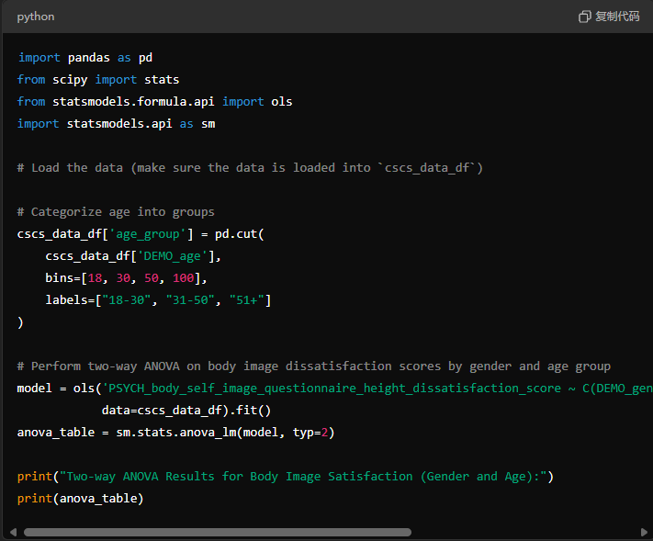

**2. Exploration of Geographic Distribution and Mental Health Scores**

**Objective**: To explore whether mental health outcomes vary significantly across different provinces.

* **Variables to Explore**:
  + **Geographic Location** (GEO_province): The province variable identifies participants’ province of residence within Canada.
  + **Mental Health Scores**:
    - PSYCH_big_five_inventory_neurotic_score: Reflects neuroticism, which is often linked to emotional instability.
    - PSYCH_big_five_inventory_agreeable_score: Measures agreeableness, related to social harmony.
    - PSYCH_big_five_inventory_conscientious_score: Measures conscientiousness, related to self-discipline.
    - PSYCH_big_five_inventory_extraverted_score: Measures extroversion, related to sociability.
    - PSYCH_big_five_inventory_open_score: Measures openness, related to open-mindedness.
* **Analysis Plan**:
  + **Descriptive Statistics**: Calculate the average mental health scores by province.
  + **ANOVA**: Conduct an ANOVA to compare mental health scores across provinces.
  + **Post Hoc Analysis**: If ANOVA results are significant, perform post hoc tests (e.g., Tukey’s test) to pinpoint specific provinces with notable differences.
* **Expected Results**:
  + Certain provinces may exhibit higher or lower levels of specific mental health traits, potentially due to regional cultural or socioeconomic factors.
  + For instance, participants from urban provinces may show different personality or mental health trends compared to rural areas.
* **Relevance**: Understanding geographic differences can highlight areas with greater mental health needs or areas where different mental health traits prevail, which could inform localized mental health strategies.



**3. LGBTQ+ Identity and Personality Traits**

**Objective**: To investigate whether LGBTQ+ identity is associated with particular personality traits.

* **Variables to Explore**:
  + **LGBTQ+ Identity** (DEMO_identity_lgbtq): Indicates whether participants identify as LGBTQ+.
  + **Personality Traits** (from the Big Five Inventory):
    - PSYCH_big_five_inventory_agreeable_score: Measures agreeableness.
    - PSYCH_big_five_inventory_conscientious_score: Measures conscientiousness.
    - PSYCH_big_five_inventory_extraverted_score: Measures extroversion.
    - PSYCH_big_five_inventory_neurotic_score: Measures neuroticism.
    - PSYCH_big_five_inventory_open_score: Measures openness.
* **Analysis Plan**:
  + **T-tests**: Compare average scores on each of the Big Five personality traits between LGBTQ+ and non-LGBTQ+ participants.
  + **Multiple Regression Analysis**: Run regression models to see if LGBTQ+ identity significantly predicts each personality trait score, controlling for other demographic factors such as age and gender.
* **Expected Results**:
  + LGBTQ+ participants may score differently on traits like openness or agreeableness, which could indicate a unique psychological profile within the community.
  + The results could reveal higher levels of openness and extraversion, or higher neuroticism levels, given past research findings.
* **Relevance**: Such findings may help to better understand the diversity of personality within the LGBTQ+ community and tailor resources or support services that resonate with personality-driven needs.

